The United Benefice of Barlborough and Clowne
Bulletin and Order of Service for the
Second Sunday of Easter 24th April 2022

St James the Greater, Barlborough

Sylvia and Gordon Bradbury
Diamond Wedding Anniversary

Today we congratulate Sylvia and Gordon Bradbury on their Diamond Wedding Anniversary! There will be a special blessing during the service and do stay after the service for refreshments, cake and prosecco!
Upcoming services and events:
Sunday 1st May Easter 3
8.30am Morning Prayer Barlborough
10am Eucharist Clowne
5pm Evensong Barlborough
Sunday 8th May Easter 4
8.30am Morning Prayer Clowne
10am Eucharist Barlborough
Sunday 15th May Easter 5
8.30am Morning Prayer Barlborough
10am Eucharist Clowne
11.15am Clowne Annual Parochial Church Meeting
Tuesday 17th May - 7pm Quiz Night at Barlborough with Cheese and Wine

We Gather to Worship God
Remain seated as the choir sings the introit
Hymn: Come let us join our cheerful songs 94
The Greeting
Alleluia. Christ is risen.
He is risen indeed. Alleluia!

Prayer of Preparation

Almighty God,
your Son has opened for us
a new and living way into your presence.
Give us new hearts and constant wills
to worship you in spirit and in truth;
through Jesus Christ our Lord.
Amen.

Prayers of Penitence
Please sit or kneel. We all call to mind our sins using these or other appropriate words:

Jesus Christ, risen Master and triumphant Lord,
we come to you in sorrow for our sins,
and confess to you our weakness and unbelief.

We have lived by our own strength,
and not by the power of your resurrection.
In your mercy, forgive us.
Lord, hear us and help us.

We have lived by the light of our own eyes,
as faithless and not believing.
In your mercy, forgive us.
Lord, hear us and help us.

We have lived for this world alone,
and doubted our home in heaven.
In your mercy, forgive us.
Lord, hear us and help us.

The president pronounces the Absolution.

May the Father of all mercies
Xcleanse you from your sins,
and restore you in his image
to the praise and glory of his name,
through Jesus Christ our Lord.
Amen.

Please stand as you are able
The Gloria
Glory to God in the highest,
and peace to his people on earth.
Lord God, heavenly King,
almighty God and Father,
we worship you, we give you thanks,
we praise you for your glory.
Lord Jesus Christ, only Son of the Father,
Lord God, Lamb of God,
you take away the sin of the world:
have mercy on us;
you are seated at the right hand of the Father:
receive our prayer.
For you alone are the Holy One,
you alone are the Lord,
you alone are the Most High, Jesus Christ,
with the Holy Spirit,
in the glory of God the Father.
Amen.

The Collect
Let us pray
Risen Christ,
for whom no door is locked, no entrance barred:
open the doors of our hearts,
that we may seek the good of others
and walk the joyful road of sacrifice and peace,
to the praise of God the Father. Amen.

Please be seated
We Listen to God’s Word
Acts 5.27–32

When they had brought them, they had them stand before the council. The high priest questioned them, ²⁸saying, ‘We gave you strict orders not to teach in this name, yet here you have filled Jerusalem with your teaching and you are determined to bring this man’s blood on us.’ ²⁹But Peter and the apostles answered, ‘We must obey God rather than any human authority.³⁰The God of our ancestors raised up Jesus, whom you had killed by hanging him on a tree. ³¹God exalted him at his right hand as Leader and Saviour, so that he might give repentance to Israel and forgiveness of sins. ³²And we are witnesses to these things, and so is the Holy Spirit whom God has given to those who obey him.’

This is the Word of the Lord,
Thanks be to God.

Revelation 1.4–8

John to the seven churches that are in Asia:
Grace to you and peace from him who is and who was and who is to come, and from the seven spirits who are before his throne, ⁵and from Jesus Christ, the faithful witness, the firstborn of the dead, and the ruler of the kings of the earth.
To him who loves us and freed us from our sins by his blood, ⁶and made us to be a kingdom, priests serving his God and Father, to him be glory and dominion for ever and ever. Amen.
⁷ Look! He is coming with the clouds;
every eye will see him,
even those who pierced him;
and on his account all the tribes of the earth will wail.
So it is to be. Amen.
8 ‘I am the Alpha and the Omega’, says the Lord God, who is and who was and who is to come, the Almighty.
This is the Word of the Lord,
Thanks be to God.

Hymn: Jesus lives! Thy terrors now 272 – please stand as you are able

Gospel Reading
Jesus Christ is risen from the dead.
Alleluia.

He has defeated the powers of death.
Alleluia.

Jesus turns our sorrow into dancing.
Alleluia.

He has the words of eternal life.
Alleluia.

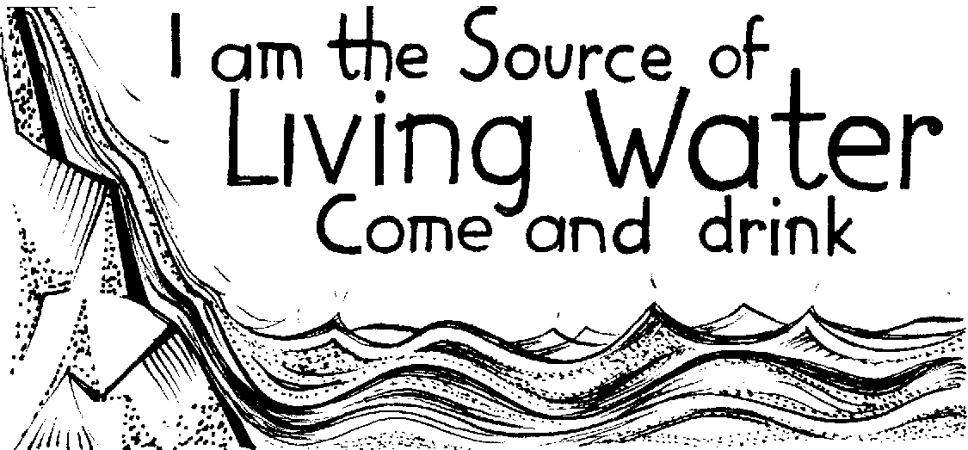

The Lord be with you
and also with you.
Hear the Gospel of our Lord Jesus Christ according to John.
Glory to you, O Lord.

19 When it was evening on that day, the first day of the week, and the doors of the house where the disciples had met were locked for fear of the Jews, Jesus came and stood among them and said, ‘Peace be with you.’ ²⁰After he said this, he showed them his hands and his side. Then the disciples rejoiced when they saw the Lord. ²¹Jesus said to them again, ‘Peace be with you. As the Father has sent me, so I send you.’ ²²When he had said this, he breathed on them and said to them, ‘Receive the Holy Spirit. ²³If you forgive the sins of any, they are forgiven them; if you retain the sins of any, they are retained.’
24 But Thomas (who was called the Twin), one of the twelve, was not with them when Jesus came. ²⁵So the other disciples told him, ‘We have seen the Lord.’ But he said to them, ‘Unless I see the mark of the nails in his hands, and put my finger in the mark of the nails and my hand in his side, I will not believe.’
26 A week later his disciples were again in the house, and Thomas was with them. Although the doors were shut, Jesus came and stood among them and said, ‘Peace be with you.’ ²⁷Then he said to Thomas, ‘Put your finger here and see my hands. Reach out your hand and put it in my side. Do not doubt but believe.’ ²⁸Thomas answered him, ‘My Lord and my God!’ ²⁹Jesus said to him, ‘Have you believed because you have seen me? Blessed are those who have not seen and yet have come to believe.’
30 Now Jesus did many other signs in the presence of his disciples, which are not written in this book. ³¹But these are written so that you may come to believe that Jesus is the Messiah, the Son of God, and that through believing you may have life in his name.

At the end:
This is the Gospel of the Lord.
Praise to you, O Christ.

Sermon please sit

The Creed

We stand to say the Creed together.

We believe in one God,
the Father, the Almighty,
maker of heaven and earth,
of all that is,
seen and unseen.

We believe in one Lord, Jesus Christ,
the only Son of God,
eternally begotten of the Father,
God from God, Light from Light,
true God from true God,
begotten, not made,
of one Being with the Father;
through him all things were made.
For us and for our salvation he came down from heaven,
was incarnate from the Holy Spirit and the Virgin Mary
and was made man.
For our sake he was crucified under Pontius Pilate;
he suffered death and was buried.
On the third day he rose again
in accordance with the Scriptures;
he ascended into heaven
and is seated at the right hand of the Father.
He will come again in glory to judge the living and the dead,
and his kingdom will have no end.

We believe in the Holy Spirit,
the Lord, the giver of life,
who proceeds from the Father and the Son,
who with the Father and the Son is worshipped and glorified,
who has spoken through the prophets.
We believe in one holy catholic and apostolic Church.
We acknowledge one baptism for the forgiveness of sins.
We look for the resurrection of the dead,
and the life of the world to come.
Amen.

We Pray

We kneel or sit for our prayers

Our prayers are asked for: Wyatt & Garrett Ruthven, Barbara Needham, Veronica Blackwell, Luke Firth, Margaret Smith, Susan Proffitt, Kath Adams, Heather Davies, Barbara Anderson, baby Amari-Rachel Towner (born 13 weeks early), Audrey Dawson, Molly Blackwell.

Those who have recently died: Marion Booth, Douglas Gray

Sylvia and Gordon Bradbury Diamond Wedding Celebration

Sylvia and Gordon are invited to the front to receive God’s blessing on the 60th anniversary of their marriage in this church (actual date 12th May 1962).

Blessed are you, heavenly Father.
All You give joy to husband and wife.

Blessed are you, Lord Jesus Christ.
All You have brought new life to mankind.

Blessed are you, Holy Spirit of God.
All You bring us together in love.

Blessed be Father, Son and Holy Spirit.
All One God, to be praised for ever. Amen.

Marriage Blessing

God the Father,
God the Son,
God the Holy Spirit,
bless, preserve and keep you;
the Lord mercifully grant you the riches of his grace
that you may please him both in body and soul,
and, living together in faith and love,
may receive the blessings of eternal life.
Amen.

Almighty God, our heavenly Father,
we lift up our hearts to you
through Jesus Christ our Lord.
Through him you have made a covenant of grace with your people
by the outpouring of your Holy Spirit.

We praise you for the gift of marriage
in which the love of husband and wife is brought together
and reflects your plan of love for the world.

We thank you today for Sylvia and Gordon,
and for leading them to each other
in friendship and love, commitment and trust,
and for bringing them here for the blessing of their marriage.

Living God,
by the presence of your Holy Spirit,
may they know the risen Christ to be with them now,
as they celebrate this covenant together.
May their lives be a witness to your saving love
in this troubled world.

As you pour out your love,
may they grow together in your sight,
and each be to the other
a companion in joy, a comfort in sorrow and a strength in need.

As you blessed the earthly home at Nazareth
with the presence of your Son,
may their home be a place of security and peace.

And bring us all at the last
to that great marriage banquet of your Son
in our home in heaven,
where, with all your saints and angels,
in the glory of your presence,
we will for ever praise you;
through Jesus Christ our Lord.
Amen.

We congratulate Sylvia and Gordon on 60 years of marriage!
We Share Holy Communion
The Peace

We stand and the president introduces the Peace.

The risen Christ came and stood among his disciples
and said, ‘Peace be with you.’
Then were they glad when they saw the Lord. Alleluia!

The peace of the Lord be always with you
and also with you. Alleluia!

Please share the peace in a safe manner!

Hymn: Love Divine all loves excelling 321

Prayer of Preparation

Risen Lord Jesus Christ,
we believe you, and all we have heard is true.
When you break bread
may we recognize you as the fire that burns within us,
that we may bring light to your world.
Amen.

The Eucharistic Prayer
The Lord be with you
and also with you.

Lift up your hearts.
We lift them to the Lord.

Let us give thanks to the Lord our God.
It is right to give thanks and praise.

It is indeed right, our duty and our joy,
always and everywhere to give you thanks,
almighty and eternal Father,
and in these days of Easter
to celebrate with joyful hearts
the memory of your wonderful works.
For by the mystery of his passion
Jesus Christ, your risen Son,
has conquered the powers of death and hell
and restored in men and women the image of your glory.
He has placed them once more in paradise
and opened to them the gate of life eternal.
And so, in the joy of this Passover,
earth and heaven resound with gladness,
while angels and archangels and the powers of all creation
sing for ever the hymn of your glory:

Holy, holy, holy Lord,
God of power and might,
heaven and earth are full of your glory.
Hosanna in the highest.
Blessed is he who comes in the name of the Lord.
Hosanna in the highest.

Lord, you are holy indeed, the source of all holiness;
grant that by the power of your Holy Spirit,
and according to your holy will,
these gifts of bread and wine
may be to us the body and blood of our Lord Jesus Christ;
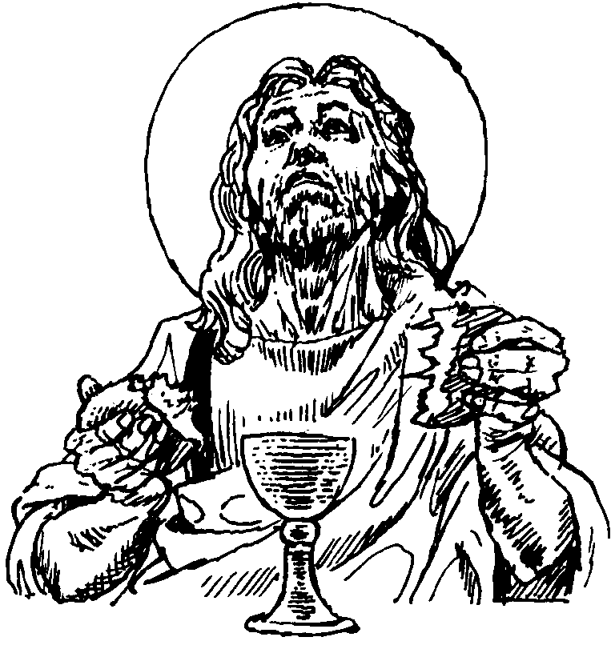
who, in the same night that he was betrayed,
took bread and gave you thanks;
he broke it and gave it to his disciples, saying:
Take, eat; this is my body which is given for you;
do this in remembrance of me.
In the same way, after supper
he took the cup and gave you thanks;
he gave it to them, saying:
Drink this, all of you;
this is my blood of the new covenant,
which is shed for you and for many for the forgiveness of sins.
Do this, as often as you drink it, in remembrance of me.
Christ has died:
Christ is risen:
Christ will come again.

And so, Father, calling to mind his death on the cross,
his perfect sacrifice made once for the sins of the whole world;
rejoicing in his mighty resurrection and glorious ascension,
and looking for his coming in glory,
we celebrate this memorial of our redemption.
As we offer you this our sacrifice of praise and thanksgiving,
we bring before you this bread and this cup
and we thank you for counting us worthy
to stand in your presence and serve you.

Send the Holy Spirit on your people
and gather into one in your kingdom
all who share this one bread and one cup,
so that we, in the company of Mary the Mother of Christ,
St John the Baptist, St James and all your saints
may praise and glorify you for ever,
through Jesus Christ our Lord;
by whom, and with whom, and in whom,
in the unity of the Holy Spirit,
all honour and glory be yours, almighty Father,
for ever and ever. Amen.
The Lord’s Prayer
We kneel or sit to pray as Jesus taught us
Rejoicing in God’s new creation,
as our Saviour taught us, so we pray

Our Father, who art in heaven,
hallowed be thy name;
thy kingdom come;
thy will be done;
on earth as it is in heaven.
Give us this day our daily bread.
And forgive us our trespasses,
as we forgive those who trespass against us.
And lead us not into temptation;
but deliver us from evil.
For thine is the kingdom,
the power and the glory,
for ever and ever.
Amen.

Breaking of the Bread
Jesus says, I am the bread of life,
whoever eats this bread will live for ever.
Lord, our hearts hunger for you;
give us this bread always.

Giving of Communion
The president says the invitation to communion

Alleluia! Christ our Passover has been sacrificed for us,
Therefore let us keep the feast. Alleluia!

All are welcome at the table of Jesus Christ, for he bids us come.
If you would like to come for a blessing please bring this service book with you.
Communion Hymn: There is a Redeemer 500
The choir sings the anthem

We pray after Communion
We stand to pray together

God of truth,
we have seen with our eyes
and touched with our hands
the bread of life:
strengthen our faith
that we may grow in love for you
and for each other;
through Jesus Christ our Lord.
Amen.

Hymn: Lord enthroned in heavenly splendour 309

We go out to serve God
The Dismissal
Alleluia. Christ is risen.
He is risen indeed. Alleluia.
Praise the God and Father of our Lord Jesus Christ.
He has given us new life and hope.
He has raised Jesus from the dead.
God has claimed us as his own.
He has brought us out of darkness.
He has made us light to the world.
Alleluia. Christ is risen.
He is risen indeed. Alleluia.

Let us bow our heads to receive God’s blessing.
May Christ,
who out of defeat brings new hope and a new future,
fill you with his new life;
and the blessing of God Almighty,
Father, Son and Holy Spirit,
be among you and
remain with you this day and always. Amen.

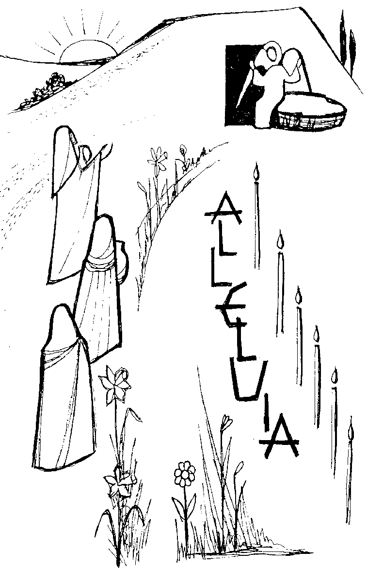
The deacon dismisses the congregation:
With the power that raised Jesus from the dead at work within you,
go in peace to love and serve the Lord. Alleluia, alleluia!
In the name of Christ. Amen. Alleluia, alleluia!

