The United Benefice of Barlborough and Clowne
St John the Baptist, Clowne
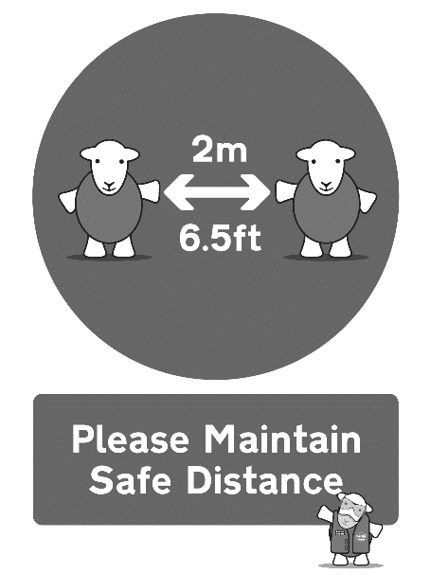
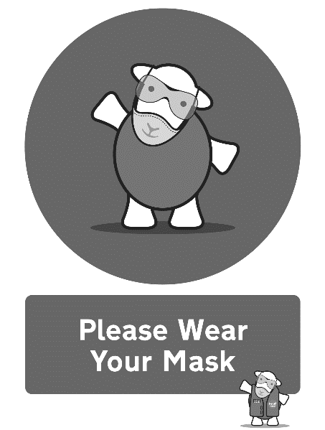
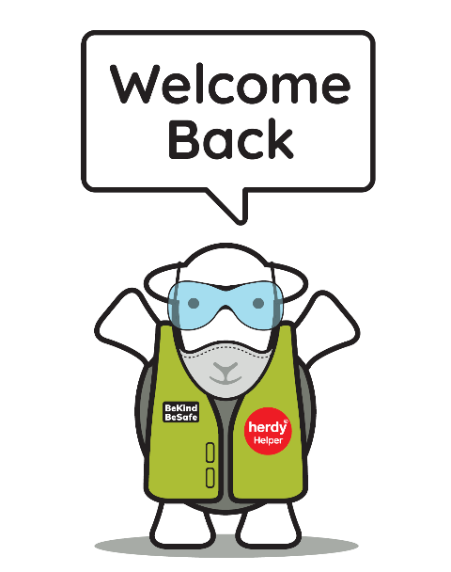

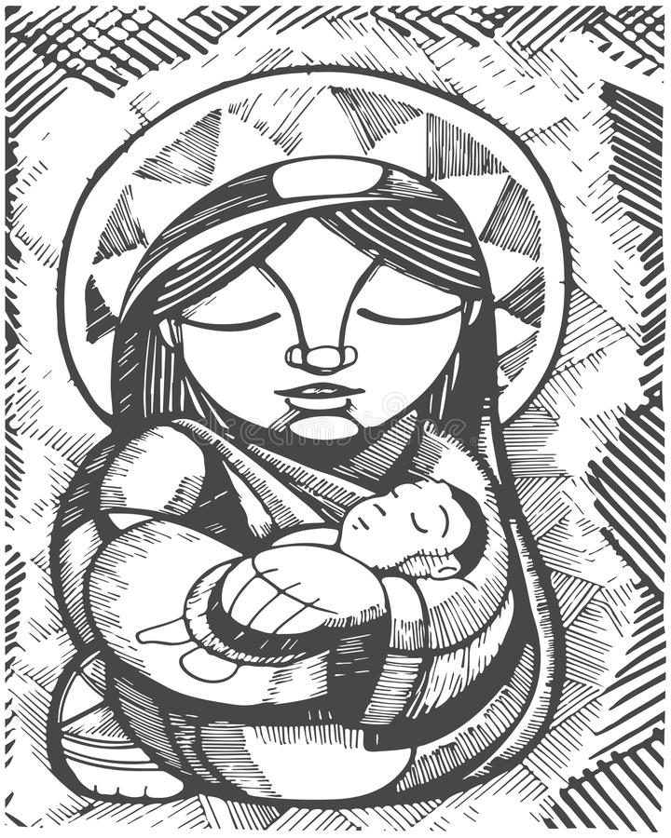

Eucharist for the Fourth Sunday of Advent
Sunday 19th December 2021

Please take this order of service home with you
Notices
Just a reminder that mask wearing is now mandatory in places of worship as part of the Government's introduction of Plan B. However, we can still sing hymns! So don't forget your mask when you come to church. Remember, my mask protects you, your mask protects me - love your neighbour!

I hope you can join us at our carol services this week:

Sunday 19th December 5pm – Barlborough
Tuesday 21st December 7pm – Clowne

Please take some raffle tickets to sell to friends and family – this will be drawn at the carol services.

Christmas Appeal 2021 – supporting the Freedom Project

For this year’s Christmas appeal we are supporting the Freedom Project with their work with families and the homeless. Please bring along to church a toy up to the value of £5 or toiletries/warm socks/gloves up to the value of £5. Please leave these unwrapped so that the project workers can allocate them to the right recipients (they know the families well). You might find it easiest to put them in a gift bag, but it is fine if they are loose – they will be wrapped by staff at the Freedom Project. Place these gifts in front of the altar at church, you can bring them any time up until the Carol Services on 19th December at Barlborough and 21st December at Clowne. After this date, please drop off items at the Rectory, Church Street, Barlborough.

Please leave any collection money on the plate provided at the back of church or even better, set up a direct debit by ringing this number in the week: 0333 002 1271. You will need your bank details and the correct code for the church you wish to give to regularly.
Parish Giving Scheme codes:
St John the Baptist, Clowne: 120612060
St James the Greater, Barlborough: 120612054

Contact the clergy:

Rev’d Bryony Taylor, Rector
01246 813569
revbryonytaylor@gmail.com

Rev’d Mike Fitzsimmons, Assistant Curate
07385 292902
rev.mike.fitz@gmail.com

Please note that the clergy’s usual day off is a Friday. Find out other information about our churches on our website: http://bcjj.org.uk

These are our upcoming service and event times for your diary:

Sunday 19th December – Fourth Sunday of Advent

8.30am Morning Prayer, Barlborough
10.00am Benefice Eucharist, Clowne
5.00pm Traditional 9 Lessons and Carols at Barlborough

Tuesday 21st December - 7pm 9 Lessons and Carols at Clowne

Christmas Eve
4pm Family Crib and Carol Service at Clowne
6pm Family Crib and Carol Service at Barlborough
11.30pm Midnight Mass at Barlborough and Clowne

Christmas Day - 9.15am Festival Eucharist at Clowne
Sunday 26th December - 9.15am Said Eucharist for St Stephen in the Lady Chapel

Sunday 2nd January - Epiphany
8.30am Morning Prayer, Barlborough
10.00am Benefice Eucharist, Clowne

Sunday 9th January – Epiphany 1 – Baptism of Christ
8.30am Morning Prayer, Clowne
10.00am Benefice Eucharist, Barlborough
2.30pm & 3.30pm Baptisms Barlborough
OPENING HYMN

Please stand as you are able

313 For Mary, Mother of our Lord

THE GREETING
In the name of the Father,
and of the Son,
and of the Holy Spirit. Amen.
Grace, mercy and peace
from God our Father
and the Lord Jesus Christ
be with you and also with you.

LIGHTING THE ADVENT WREATH

People of God: prepare!
God, above all, maker of all,
is one with us in Christ.
Maranatha!
Come, Lord Jesus!

God, the mighty God,
bends down in love to earth.
Maranatha!
Come, Lord Jesus!

God with us, God beside us,
comes soon to the world he has made.
Maranatha!
Come, Lord Jesus!

We are God’s children,
we seek the coming Christ.
Maranatha!
Come, Lord Jesus!

Please be seated
WE CONFESS OUR SINS
When the Lord comes, he will bring to light the things now hidden in darkness,
and will disclose the purposes of the heart. Therefore in the light of Christ let us confess our sins.

Lord Jesus, you came to gather the nations into the peace of your kingdom:
Lord, have mercy.
Lord, have mercy.

You come in word and sacrament
to strengthen us in holiness:
Christ, have mercy.
Christ, have mercy.

You will come in glory
with salvation for your people:
Lord, have mercy.
Lord, have mercy.

May the God of love and power
forgive you and free you from your sins,
heal and strengthen you by his Spirit,
and raise you to new life in Christ our Lord.
Amen.

THE GLORIA
Please stand as we sing the Gloria
Glory to God in the highest,
and peace to his people on earth.
Lord God, heavenly King,
almighty God and Father,
we worship you, we give you thanks,
we praise you for your glory.
Lord Jesus Christ, only Son of the Father,
Lord God, Lamb of God,
you take away the sin of the world:
have mercy on us;
you are seated at the right hand of the Father:
receive our prayer.
For you alone are the Holy One,
you alone are the Lord,
you alone are the Most High, Jesus Christ,
with the Holy Spirit,
in the glory of God the Father.
Amen.

THE COLLECT
The president introduces a period of silent prayer.
As we stand, let us pray.
Eternal God,
as Mary waited for the birth of your Son,
so we wait for his coming in glory;
bring us through the birth pangs of this present age
to see, with her, our great salvation
in Jesus Christ our Lord. Amen.
Please sit
BIBLE READINGS
Micah 5.2–5a
But you, O Bethlehem of Ephrathah,
who are one of the little clans of Judah,
from you shall come forth for me
one who is to rule in Israel,
whose origin is from of old,
from ancient days.
³ Therefore he shall give them up until the time
when she who is in labour has brought forth;
then the rest of his kindred shall return
to the people of Israel.
⁴ And he shall stand and feed his flock in the strength of the Lord,
in the majesty of the name of the Lord his God.
And they shall live secure, for now he shall be great
to the ends of the earth;
⁵ and he shall be the one of peace.
If the Assyrians come into our land
and tread upon our soil,
we will raise against them seven shepherds
and eight installed as rulers.
This is the word of the Lord. Thanks be to God.
Hebrews 10.5–10
Consequently, when Christ came into the world, he said,
‘Sacrifices and offerings you have not desired,
but a body you have prepared for me;
⁶ in burnt-offerings and sin-offerings
you have taken no pleasure.
⁷ Then I said, “See, God, I have come to do your will, O God”
(in the scroll of the book it is written of me).’
⁸When he said above, ‘You have neither desired nor taken pleasure in sacrifices and offerings and burnt-offerings and sin-offerings’ (these are offered according to the law), ⁹then he added, ‘See, I have come to do your will.’ He abolishes the first in order to establish the second. ¹⁰And it is by God’s will that we have been sanctified through the offering of the body of Jesus Christ once for all.
This is the word of the Lord. Thanks be to God.

GRADUAL HYMN Please stand as you are able
85 The angel Gabriel from heaven came

GOSPEL READING
Please remain standing and face the deacon as he reads the Gospel
Alleluia, alleluia.
Prepare the way of the Lord, make his paths straight,
and all flesh shall see the salvation of God.
cf Isaiah 40.3–5
Alleluia.

The Lord be with you
and also with you.
Hear the Gospel of our Lord Jesus Christ according to Luke.
Glory to you, O Lord.
Luke 1.39–55
In those days Mary set out and went with haste to a Judean town in the hill country, ⁴⁰where she entered the house of Zechariah and greeted Elizabeth. ⁴¹When Elizabeth heard Mary’s greeting, the child leapt in her womb. And Elizabeth was filled with the Holy Spirit ⁴²and exclaimed with a loud cry, ‘Blessed are you among women, and blessed is the fruit of your womb. ⁴³And why has this happened to me, that the mother of my Lord comes to me? ⁴⁴For as soon as I heard the sound of your greeting, the child in my womb leapt for joy. ⁴⁵And blessed is she who believed that there would be a fulfilment of what was spoken to her by the Lord.’
46 And Mary said,
‘My soul magnifies the Lord,
⁴⁷ and my spirit rejoices in God my Saviour,
⁴⁸ for he has looked with favour on the lowliness of his servant.
Surely, from now on all generations will call me blessed;
⁴⁹ for the Mighty One has done great things for me,
and holy is his name.
⁵⁰ His mercy is for those who fear him
from generation to generation.
⁵¹ He has shown strength with his arm;
he has scattered the proud in the thoughts of their hearts.
⁵² He has brought down the powerful from their thrones,
and lifted up the lowly;
⁵³ he has filled the hungry with good things,
and sent the rich away empty.
⁵⁴ He has helped his servant Israel,
in remembrance of his mercy,
⁵⁵ according to the promise he made to our ancestors,
to Abraham and to his descendants for ever.’
This is the Gospel of the Lord. Praise to you, O Christ.
Please sit for THE SERMON
THE APOSTLES’ CREED
Please stand as you are able

Do you believe and trust in God the Father?
I believe in God, the Father almighty, creator of heaven and earth.
Do you believe and trust in his Son Jesus Christ?
I believe in Jesus Christ, his only Son, our Lord, who was conceived by the Holy Spirit, born of the Virgin Mary, suffered under Pontius Pilate, was crucified, died, and was buried; he descended to the dead. On the third day he rose again; he ascended into heaven, he is seated at the right hand of the Father, and he will come to judge the living and the dead.
Do you believe and trust in the Holy Spirit?
I believe in the Holy Spirit, the holy catholic Church, the communion of saints, the forgiveness of sins, the resurrection of the body, and the life everlasting. Amen.

PRAYERS OF INTERCESSION
We kneel or sit for our prayers.
Maranatha:
Amen. Come, Lord Jesus.

This week our prayers are asked for:
The sick and in need:
Wyatt & Garrett Ruthven, Barbara Needham, Veronica Blackwell, Luke Firth, Chloe Parkes, Betty Wood, Lillie Wood, Richard Abbiss, Margaret Malpass, Scarlett Bolton (3), Susan Proffitt, Joan Phillimore, Alan Taylor, Steve Short, Kath Adams, Heather Davies, Pat Ashley, Barbara Anderson
The dearly departed:
Rachel Towner, John Armfield, Mildred Smith, Samantha Thornton

We Share Holy Communion
The Peace
We stand and the president introduces the Peace.
In the tender mercy of our God,
the dayspring from on high shall break upon us,
to give light to those who dwell in darkness
and in the shadow of death,
and to guide our feet into the way of peace.
cf Luke 1.78,79
The peace of the Lord be always with you.
and also with you.

Please share the peace in a safe manner!

OFFERTORY HYMN
Please remain standing as you are able for the offertory hymn
394 Tell out my soul

PRAYER AT THE PREPARATION OF THE TABLE
Look upon us in mercy not in judgement;
draw us from hatred to love;
make the frailty of our praise
a dwelling place for your glory.
Amen.

THE EUCHARISTIC PRAYER
Please stand as you are able
The Lord be with you
and also with you

Lift up your hearts
We lift them to the Lord

Let us give thanks to the Lord our God
It is right to give thanks and praise

It is indeed right and good to give you thanks and praise,
almighty God and everlasting Father,
through Jesus Christ your Son.
He is the one foretold by all the prophets,
whom the Virgin Mother bore with love beyond all telling.
John the Baptist was his herald
and made him known when at last he came.
In his love Christ fills us with joy
as we prepare to celebrate his birth,
so that when he comes again he may find us watching in prayer,
our hearts filled with wonder and praise.
And so, with angels and archangels,
and with all the company of heaven,
we proclaim your glory,
and join in their unending hymn of praise:

Holy, holy, holy Lord,
God of power and might,
heaven and earth are full of your glory.
Hosanna in the highest.
Blessed is he who comes in the name of the Lord.
Hosanna in the highest.

Please be seated
Lord, you are holy indeed, the source of all holiness;
grant that by the power of your Holy Spirit,
and according to your holy will,
these gifts of bread and wine
may be to us the body and blood of our Lord Jesus Christ;
who, in the same night that he was betrayed,
took bread and gave you thanks;
he broke it and gave it to his disciples, saying:
Take, eat; this is my body
which is given for you;
do this in remembrance of me.
In the same way, after supper
he took the cup and gave you thanks;
he gave it to them, saying:
Drink this, all of you;
this is my blood of the new covenant,
which is shed for you and for all
for the forgiveness of sins.
Do this, as often as you drink it,
in remembrance of me.

Great is the mystery of faith…
Christ has died, Christ is risen, Christ will come again
And so, Father, calling to mind his death on the cross,
his perfect sacrifice made once for the sins
of the whole world;
rejoicing in his mighty resurrection
and glorious ascension,
and looking for his coming in glory,
we celebrate this memorial of our redemption.
As we offer you this our sacrifice
of praise and thanksgiving,
we bring before you this bread and this cup
and we thank you for counting us worthy
to stand in your presence and serve you.
Send the Holy Spirit on your people
and gather into one in your kingdom
all who share this one bread and one cup,
so that we, in the company of
the Blessed Virgin Mary, St John the Baptist, St James
and all the angels and saints,
may praise and glorify you for ever,
through Jesus Christ our Lord;
by whom, and with whom, and in whom,
in the unity of the Holy Spirit,
all honour and glory be yours, almighty Father,
for ever and ever. Amen.

THE LORD’S PRAYER

Looking for the coming of his Kingdom, as our Saviour taught us, so we pray:

Our Father, who art in heaven,
hallowed be thy name;
thy kingdom come;
thy will be done;
on earth as it is in heaven.
Give us this day our daily bread.
And forgive us our trespasses,
as we forgive those who trespass against us.
And lead us not into temptation;
but deliver us from evil.
For thine is the kingdom,
the power and the glory,
for ever and ever. Amen.

BREAKING OF THE BREAD

We break this bread to share in the body of Christ.
Though we are many, we are one body,
because we all share in one bread.

AGNUS DEI we sing

Lamb of God you take away, the sins of the world, have mercy on us.
Lamb of God you take away, the sins of the world, have mercy on us.
Lamb of God you take away, the sins of the world, grant us peace.

THE GIVING OF COMMUNION

Jesus is the Lamb of God
who takes away the sin of the world.
Blessed are those who are called to his supper.
Lord, I am not worthy to receive you,
but only say the word, and I shall be healed.

Please come to receive communion when prompted and follow the markings on the floor to remain at safe physical distance. Take your time, no need to rush. Please bring this booklet with you if you would prefer a blessing. Please wear a mask as you move around the building (unless you’re exempt).

COMMUNION HYMN
785 Such love

PRAYERS AFTER COMMUNION
Heavenly Father,
who chose the Blessed Virgin Mary
to be the mother of the promised saviour:
fill us your servants with your grace,
that in all things we may embrace your holy will
and with her rejoice in your salvation;
through Jesus Christ our Lord. Amen.

Almighty God,
we thank you for feeding us
with the body and blood of your Son Jesus Christ.
Through him we offer you our souls and bodies
to be a living sacrifice.
Send us out
in the power of your Spirit
to live and work
to your praise and glory.
Amen.

FINAL HYMN

719 Lord the Light of your Love is Shining

THE BLESSING

The Lord be with you and also with you.
Let us bow our heads to receive God’s blessing.

Christ the Sun of Righteousness shine upon you,
scatter the darkness from before your path,
and make you ready to meet him when he comes in glory;

and the blessing of God almighty,
the +Father, the Son, and the Holy Spirit,
be among you and remain with you always.
Amen.

THE DISMISSAL

The deacon dismisses the congregation:

Go in peace to love and serve the Lord.
In the name of Christ. Amen.

