The United Benefice of Barlborough and Clowne
St John the Baptist, Clowne
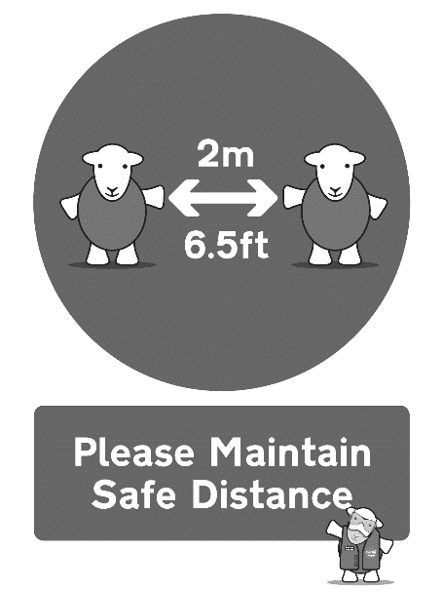
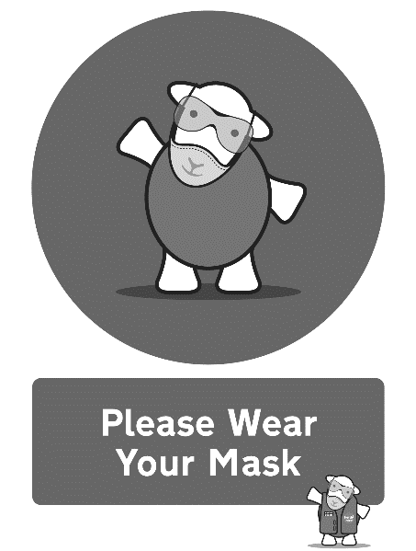
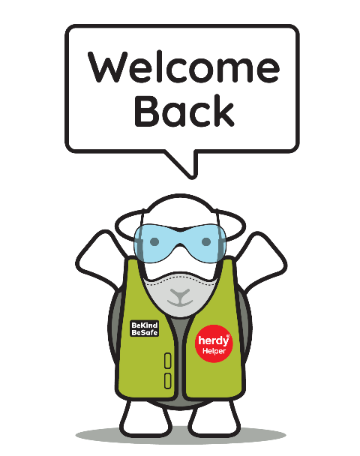

Eucharist for Christ the King
Sunday 21st November 2021

Please take this order of service home with you
Notices
The Rector is away this weekend at a family reunion but is back at work on Monday 22nd November. Thank you to Rev’d Adrian Murray-Leslie for taking the service today.
Please support our events next weekend - Clowne Christmas Fair on Saturday 27th November 10am-1pm and Barlborough Christmas Market on Sunday 28th November 2-6pm. After the light switch on at 6pm on the village green, come along to church for mulled wine and mince pies and then a beautiful Advent Christingle Carol Service at 6.30pm at St James. Please tell your friends and neighbours! And please come and spend lots of money. There will be an opportunity to make a christingle in the village hall on Sunday afternoon.
Also, on Saturday 4th December the Ruthven Trust is running a Christmas Craft Market at the Community Centre - please do support this.

Contact the clergy:

Rev’d Bryony Taylor, Rector
01246 813569
revbryonytaylor@gmail.com

Rev’d Mike Fitzsimmons, Assistant Curate
07385 292902
rev.mike.fitz@gmail.com

Please note that the clergy’s usual day off is a Friday. Find out other information about our churches on our website: http://bcjj.org.uk

These are our upcoming service and event times for your diary:
Saturday 27th November –
Clowne Christmas Fair
10am-1pm

Sunday 28th November – Advent Sunday
8.30am Morning Prayer, Clowne

10.00am Benefice Eucharist, Barlborough

Afternoon – free fair in Barlborough Village on the green, make a Christingle in the Village Hall to bring to the service.
After the lights switch on at 6pm mulled wine and mince pies will be available in church.
6.30pm Advent Carols Christingle Service Barlborough (after light switch on in village)

Sunday 5th December – Second Sunday of Advent

8.30am Morning Prayer, Barlborough
10.00am Benefice Eucharist, Clowne

Sunday 12th December – Third Sunday of Advent

8.30am Morning Prayer, Clowne
10.00am Benefice Eucharist, Barlborough
5pm – Light of Life Christmas Memorial Service at Barlborough – dedicate a light on our Christmas Tree

Tuesday 14th December - 7pm Light of Life Christmas Memorial Service at Clowne - Dedicate a light on our Christmas Tree

Sunday 19th December – Fourth Sunday of Advent

8.30am Morning Prayer, Barlborough
10.00am Benefice Eucharist, Clowne
5.00pm Traditional 9 Lessons and Carols at Barlborough

Tuesday 21st December - 7pm 9 Lessons and Carols at Clowne

Christmas Eve
4pm Family Crib and Carol Service at Clowne
6pm Family Crib and Carol Service at Barlborough
11.30pm Midnight Mass at Barlborough and Clowne

Christmas Day - 9.15am Festival Eucharist at Clowne

Sunday 26th December - 9.15am Said Eucharist for St Stephen in the Lady Chapel

Please stand as you are able

OPENING HYMN
312 Ye watchers and ye holy ones

Please be seated

THE GREETING
In the name of the Father,
and of the Son,
and of the Holy Spirit. Amen.
Grace, mercy and peace
from God our Father
and the Lord Jesus Christ
be with you and also with you.
Prayers of Penitence
The Deacon calls us to reflect on our sins:

God so loved the world
that he gave his only Son Jesus Christ
to save us from our sins,
to be our advocate in heaven,
and to bring us to eternal life.
Let us confess our sins in penitence and faith,
firmly resolved to keep God’s commandments
and to live in love and peace with all.

Almighty God, our heavenly Father,
we have sinned against you
and against our neighbour
in thought and word and deed,
through negligence, through weakness,
through our own deliberate fault.
We are truly sorry
and repent of all our sins.
For the sake of your Son Jesus Christ,
who died for us,
forgive us all that is past
and grant that we may serve you in newness of life
to the glory of your name.
Amen.

The president says the absolution.

XMay the Father forgive you
by the death of his Son
and strengthen us
to live in the power of the Spirit
all our days. Amen.

THE GLORIA
Please stand as we sing the Gloria
Glory to God in the highest,
and peace to his people on earth.
Lord God, heavenly King,
almighty God and Father,
we worship you, we give you thanks,
we praise you for your glory.
Lord Jesus Christ, only Son of the Father,
Lord God, Lamb of God,
you take away the sin of the world:
have mercy on us;
you are seated at the right hand of the Father:
receive our prayer.
For you alone are the Holy One,
you alone are the Lord,
you alone are the Most High, Jesus Christ,
with the Holy Spirit,
in the glory of God the Father.
Amen.

THE COLLECT
The president introduces a period of silent prayer.
As we stand, let us pray.
God the Father,
help us to hear the call of Christ the King
and to follow in his service,
whose kingdom has no end;
for he reigns with you and the Holy Spirit,
one God, one glory. Amen.
Please sit
BIBLE READINGS
Daniel 7.9–10,13,14
As I watched,
thrones were set in place,
and an Ancient One took his throne;
his clothing was white as snow,
and the hair of his head like pure wool;
his throne was fiery flames,
and its wheels were burning fire.
¹⁰ A stream of fire issued
and flowed out from his presence.
A thousand thousand served him,
and ten thousand times ten thousand stood attending him.
The court sat in judgement,
and the books were opened. ¹³As I watched in the night visions,
I saw one like a human being
coming with the clouds of heaven.
And he came to the Ancient One
and was presented before him.
¹⁴ To him was given dominion
and glory and kingship,
that all peoples, nations, and languages
should serve him.
His dominion is an everlasting dominion
that shall not pass away,
and his kingship is one
that shall never be destroyed.
This is the word of the Lord. Thanks be to God.
Revelation 1.4b–8
John to the seven churches that are in Asia:
Grace to you and peace from him who is and who was and who is to come, and from the seven spirits who are before his throne, ⁵and from Jesus Christ, the faithful witness, the firstborn of the dead, and the ruler of the kings of the earth.
To him who loves us and freed us from our sins by his blood, ⁶and made us to be a kingdom, priests serving his God and Father, to him be glory and dominion for ever and ever. Amen.
⁷ Look! He is coming with the clouds;
every eye will see him,
even those who pierced him;
and on his account all the tribes of the earth will wail.
So it is to be. Amen.
8 ‘I am the Alpha and the Omega’, says the Lord God, who is and who was and who is to come, the Almighty.
This is the word of the Lord. Thanks be to God.

GRADUAL HYMN Please stand as you are able
422 Alleluia! Sing to Jesus

GOSPEL READING
Please remain standing and face the deacon as he reads the Gospel
The Lord be with you
and also with you.
Hear the Gospel of our Lord Jesus Christ according to Mark.
Glory to you, O Lord.
Mark 1.14–20
Now after John was arrested, Jesus came to Galilee, proclaiming the good news of God,¹⁵and saying, ‘The time is fulfilled, and the kingdom of God has come near; repent, and believe in the good news.’
16 As Jesus passed along the Sea of Galilee, he saw Simon and his brother Andrew casting a net into the lake—for they were fishermen. ¹⁷And Jesus said to them, ‘Follow me and I will make you fish for people.’ ¹⁸And immediately they left their nets and followed him. ¹⁹As he went a little farther, he saw James son of Zebedee and his brother John, who were in their boat mending the nets. ²⁰Immediately he called them; and they left their father Zebedee in the boat with the hired men, and followed him.
This is the Gospel of the Lord. Praise to you, O Christ.

Please sit for THE SERMON

The Nicene Creed We stand to say the Creed together.
We believe in one God,
the Father, the Almighty,
maker of heaven and earth,
of all that is,
seen and unseen.

We believe in one Lord, Jesus Christ,
the only Son of God,
eternally begotten of the Father,
God from God, Light from Light,
true God from true God,
begotten, not made,
of one Being with the Father;
through him all things were made.
For us and for our salvation he came down from heaven,
was incarnate from the Holy Spirit and the Virgin Mary
and was made man.
For our sake he was crucified under Pontius Pilate;
he suffered death and was buried.
On the third day he rose again
in accordance with the Scriptures;
he ascended into heaven
and is seated at the right hand of the Father.
He will come again in glory to judge the living and the dead,
and his kingdom will have no end.

We believe in the Holy Spirit,
the Lord, the giver of life,
who proceeds from the Father and the Son,
who with the Father and the Son is worshipped and glorified,
who has spoken through the prophets.
We believe in one holy catholic and apostolic Church.
We acknowledge one baptism for the forgiveness of sins.
We look for the resurrection of the dead,
and the life of the world to come. Amen.

PRAYERS OF INTERCESSION
We kneel or sit for our prayers. After each prayer we respond
Lord in your mercy
hear our prayer.

This week our prayers are asked for:
The sick and in need:
Wyatt & Garrett Ruthven, Barbara Needham, Veronica Blackwell, Luke Firth, Chloe Parkes, Betty Wood, Lillie Wood, Richard Abbiss, Margaret Malpass, Scarlett Bolton (3), Susan Proffitt, Joan Phillimore, Alan Taylor, Steve Short, Kath Adams, Heather Davies, Pat Ashley, Barbara Anderson
The dearly departed:
Ena Hill, Sylvia Linacre, Rachel Towner
We Share Holy Communion
The Peace
We stand and the president introduces the Peace.

To crown all things there must be love,
to bind all together and complete the whole.
Let the peace of Christ rule in our hearts.
Colossians 3.14,15

The peace of the Lord be always with you.
and also with you.

Please share the peace in a safe manner!

OFFERTORY HYMN
Please remain standing as you are able for the offertory hymn
489 From heaven you came helpless babe

PRAYER AT THE PREPARATION OF THE TABLE
To you we come, Father of lights,
with angels and saints,
where heaven and earth unite.
May Jesus meet us in the breaking of the bread.
Amen.

THE EUCHARISTIC PRAYER
Please stand as you are able
The Lord be with you
and also with you

Lift up your hearts
We lift them to the Lord

Let us give thanks to the Lord our God
It is right to give thanks and praise

It is indeed right, our duty and our joy,
that we should always sing of your glory,
holy Father, almighty and eternal God,
through Jesus Christ your Son our Lord.
For you are the hope of the nations,
the builder of the city that is to come.
Your love made visible in Jesus Christ
brings home the lost,
restores the sinner
and gives dignity to the despised.
In his face your light shines out,
flooding lives with goodness and truth,
gathering into one in your kingdom
a divided and broken humanity.
Therefore with all who can give voice in your creation
we glorify your name,
for ever praising you and singing:

Holy, holy, holy Lord,
God of power and might,
heaven and earth are full of your glory.
Hosanna in the highest.
+Blessed is he who comes in the name of the Lord.
Hosanna in the highest.
Please be seated

We praise and bless you, loving Father,
through Jesus Christ, our Lord;
and as we obey his command,
send your Holy Spirit,
that broken bread and wine outpoured
may be for us the body and blood of your dear Son.

On the night before he died he had supper with his friends
and, taking bread, he praised you.
He broke the bread, gave it to them and said:
Take, eat; this is my body which is given for you;
do this in remembrance of me.
When supper was ended he took the cup of wine.
Again he praised you, gave it to them and said:
Drink this, all of you this is my blood of the new covenant,
which is shed for you and for many for the forgiveness of sins.
Do this, as often as you drink it, in remembrance of me.
So, Father, we remember all that Jesus did,
in him we plead with confidence his sacrifice
made once for all upon the cross.

Bringing before you the bread of life and cup of salvation,
we proclaim his death and resurrection
until he comes in glory.
Great is the mystery of faith…
Christ has died,
Christ is risen,
Christ will come again

Lord of all life,
help us to work together for that day
when your kingdom comes
and justice and mercy will be seen in all the earth.
Look with favour on your people,
gather us in your loving arms
and bring us with the Blessed Virgin Mary, St John the Baptist, St James
and all the saints to feast at your table in heaven.

Through Christ, and with Christ, and in Christ,
in the unity of the Holy Spirit, all honour and glory are yours,
O loving Father, for ever and ever. Amen.

THE LORD’S PRAYER

Looking for the coming of his Kingdom, as our Saviour taught us, so we pray:

Our Father, who art in heaven,
hallowed be thy name;
thy kingdom come;
thy will be done;
on earth as it is in heaven.
Give us this day our daily bread.
And forgive us our trespasses,
as we forgive those who trespass against us.
And lead us not into temptation;
but deliver us from evil.
For thine is the kingdom,
the power and the glory,
for ever and ever. Amen.

BREAKING OF THE BREAD

Every time we eat this bread
and drink this cup,
we proclaim the Lord’s death
until he comes.

AGNUS DEI we sing

Lamb of God you take away, the sins of the world, have mercy on us.
Lamb of God you take away, the sins of the world, have mercy on us.
Lamb of God you take away, the sins of the world, grant us peace.

THE GIVING OF COMMUNION

Jesus is the Lamb of God
who takes away the sin of the world.
Blessed are those who are called to his supper.
Lord, I am not worthy to receive you,
but only say the word, and I shall be healed.

Please come to receive communion when prompted and follow the markings on the floor to remain at safe physical distance. Take your time, no need to rush. Please bring this booklet with you if you would prefer a blessing. Please wear a mask as you move around the building (unless you’re exempt).

COMMUNION HYMN
794 The King of Love My Shepherd Is

PRAYERS AFTER COMMUNION
Stir up, O Lord,
the wills of your faithful people;
that they, plenteously bringing forth the fruit of good works,
may by you be plenteously rewarded;
through Jesus Christ our Lord. Amen.

Almighty God,
we thank you for feeding us
with the body and blood of your Son Jesus Christ.
Through him we offer you our souls and bodies
to be a living sacrifice.
Send us out
in the power of your Spirit
to live and work
to your praise and glory.
Amen.
FINAL HYMN

227 Crown him with many crowns

THE BLESSING

The Lord be with you
And also with you

Christ our King make you faithful and strong to do his will,
that you may reign with him in glory;
and the blessing of God almighty, the Father, the Son, and the Holy Spirit, be among you and remain with you always. Amen.

THE DISMISSAL

The deacon dismisses the congregation:

Go in peace to love and serve the Lord.
In the name of Christ. Amen.

