The United Benefice of Barlborough and Clowne
Bulletin and Order of Service for the
Third Sunday of Easter 1st May 2022

St John the Baptist, Clowne

Our Annual Parochial Church Meeting at which we will elect our church wardens and PCC members will take place after the service on Sunday 15th May at 11.15am. Please do stay for this important meeting and to find out what we have been doing over the past year.
Please sign up on the rota to either read or do the intercessions. Please also see Eileen Yewman if you are willing to help with refreshments, the more people who sign up, the less frequently you will need to do it!
Tickets for the Barlborough Quiz Night on Tuesday 17th May 7pm are available from Lois Nicholl and Pat Hall for £6 and include a wine and cheese platter.
Upcoming services and events:
Sunday 8th May Easter 4
8.30am Morning Prayer Clowne
10am Eucharist Barlborough
Wednesday 4th May
11.00am Funeral of Douglas Gray, Clowne
Sunday 15th May Easter 5
8.30am Morning Prayer Barlborough
10am Eucharist Clowne
11.15am Clowne Annual Parochial Church Meeting
Tuesday 17th May - 7pm Quiz Night at Barlborough with Cheese and Wine

We Gather to Worship God
Hymn: 194 Alleluia, Alleluia!
The Greeting
Alleluia. Christ is risen.
He is risen indeed. Alleluia!

Prayer of Preparation

Almighty God,
your Son has opened for us
a new and living way into your presence.
Give us new hearts and constant wills
to worship you in spirit and in truth;
through Jesus Christ our Lord.
Amen.

Prayers of Penitence
Please sit or kneel. We all call to mind our sins using these or other appropriate words:

Jesus Christ, risen Master and triumphant Lord,
we come to you in sorrow for our sins,
and confess to you our weakness and unbelief.

We have lived by our own strength,
and not by the power of your resurrection.
In your mercy, forgive us.
Lord, hear us and help us.

We have lived by the light of our own eyes,
as faithless and not believing.
In your mercy, forgive us.
Lord, hear us and help us.

We have lived for this world alone,
and doubted our home in heaven.
In your mercy, forgive us.
Lord, hear us and help us.

The president pronounces the Absolution.

May the Father of all mercies
Xcleanse you from your sins,
and restore you in his image
to the praise and glory of his name,
through Jesus Christ our Lord.
Amen.

Please stand as you are able as we sing
The Gloria
Glory to God in the highest,
and peace to his people on earth.
Lord God, heavenly King,
almighty God and Father,
we worship you, we give you thanks,
we praise you for your glory.
Lord Jesus Christ, only Son of the Father,
Lord God, Lamb of God,
you take away the sin of the world:
have mercy on us;
you are seated at the right hand of the Father:
receive our prayer.
For you alone are the Holy One,
you alone are the Lord,
you alone are the Most High, Jesus Christ,
with the Holy Spirit,
in the glory of God the Father.
Amen.

The Collect
Let us pray
Risen Christ,
you filled your disciples with boldness and fresh hope:
strengthen us to proclaim your risen life
and fill us with your peace,
to the glory of God the Father. Amen.

Please be seated
We Listen to God’s Word
Acts 9.1–6 [7–20]

Meanwhile Saul, still breathing threats and murder against the disciples of the Lord, went to the high priest ²and asked him for letters to the synagogues at Damascus, so that if he found any who belonged to the Way, men or women, he might bring them bound to Jerusalem. ³Now as he was going along and approaching Damascus, suddenly a light from heaven flashed around him. ⁴He fell to the ground and heard a voice saying to him, ‘Saul, Saul, why do you persecute me?’ ⁵He asked, ‘Who are you, Lord?’ The reply came, ‘I am Jesus, whom you are persecuting. ⁶But get up and enter the city, and you will be told what you are to do.’ ⁷The men who were travelling with him stood speechless because they heard the voice but saw no one. ⁸Saul got up from the ground, and though his eyes were open, he could see nothing; so they led him by the hand and brought him into Damascus. ⁹For three days he was without sight, and neither ate nor drank.
10 Now there was a disciple in Damascus named Ananias. The Lord said to him in a vision, ‘Ananias.’ He answered, ‘Here I am, Lord.’ ¹¹The Lord said to him, ‘Get up and go to the street called Straight, and at the house of Judas look for a man of Tarsus named Saul. At this moment he is praying, ¹²and he has seen in a vision a man named Ananias come in and lay his hands on him so that he might regain his sight.’ ¹³But Ananias answered, ‘Lord, I have heard from many about this man, how much evil he has done to your saints in Jerusalem; ¹⁴and here he has authority from the chief priests to bind all who invoke your name.’ ¹⁵But the Lord said to him, ‘Go, for he is an instrument whom I have chosen to bring my name before Gentiles and kings and before the people of Israel; ¹⁶I myself will show him how much he must suffer for the sake of my name.’ ¹⁷So Ananias went and entered the house. He laid his hands on Saul and said, ‘Brother Saul, the Lord Jesus, who appeared to you on your way here, has sent me so that you may regain your sight and be filled with the Holy Spirit.’ ¹⁸And immediately something like scales fell from his eyes, and his sight was restored. Then he got up and was baptized, ¹⁹and after taking some food, he regained his strength.
For several days he was with the disciples in Damascus, ²⁰and immediately he began to proclaim Jesus in the synagogues, saying, ‘He is the Son of God.’

This is the Word of the Lord,
Thanks be to God.

Revelation 5.11–14

Then I looked, and I heard the voice of many angels surrounding the throne and the living creatures and the elders; they numbered myriads of myriads and thousands of thousands, ¹²singing with full voice,
‘Worthy is the Lamb that was slaughtered
to receive power and wealth and wisdom and might
and honour and glory and blessing!’
¹³Then I heard every creature in heaven and on earth and under the earth and in the sea, and all that is in them, singing,
‘To the one seated on the throne and to the Lamb
be blessing and honour and glory and might
for ever and ever!’
¹⁴And the four living creatures said, ‘Amen!’ And the elders fell down and worshipped.
This is the Word of the Lord,
Thanks be to God.

Hymn: 383 Lord thy word abideth – please stand as you are able

Gospel Reading
Jesus Christ is risen from the dead.
Alleluia.

He has defeated the powers of death.
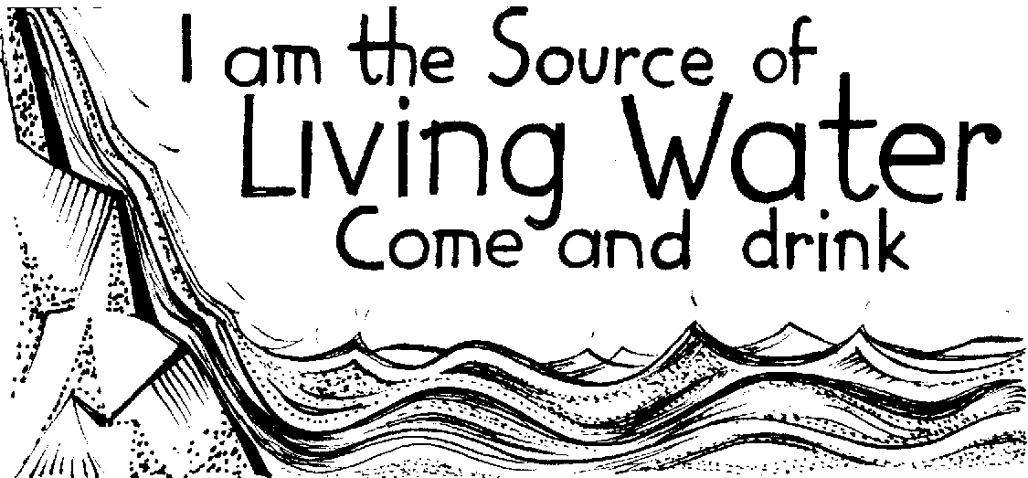
Alleluia.

Jesus turns our sorrow into dancing.
Alleluia.

He has the words of eternal life.
Alleluia.

The Lord be with you
and also with you.
Hear the Gospel of our Lord Jesus Christ according to John.
Glory to you, O Lord.

John 21.1–19

21After these things Jesus showed himself again to the disciples by the Sea of Tiberias; and he showed himself in this way. ²Gathered there together were Simon Peter, Thomas called the Twin, Nathanael of Cana in Galilee, the sons of Zebedee, and two others of his disciples. ³Simon Peter said to them, ‘I am going fishing.’ They said to him, ‘We will go with you.’ They went out and got into the boat, but that night they caught nothing.
4 Just after daybreak, Jesus stood on the beach; but the disciples did not know that it was Jesus. ⁵Jesus said to them, ‘Children, you have no fish, have you?’ They answered him, ‘No.’ ⁶He said to them, ‘Cast the net to the right side of the boat, and you will find some.’ So they cast it, and now they were not able to haul it in because there were so many fish. ⁷That disciple whom Jesus loved said to Peter, ‘It is the Lord!’ When Simon Peter heard that it was the Lord, he put on some clothes, for he was naked, and jumped into the lake. ⁸But the other disciples came in the boat, dragging the net full of fish, for they were not far from the land, only about a hundred yards off.
9 When they had gone ashore, they saw a charcoal fire there, with fish on it, and bread. ¹⁰Jesus said to them, ‘Bring some of the fish that you have just caught.’ ¹¹So Simon Peter went aboard and hauled the net ashore, full of large fish, a hundred and fifty-three of them; and though there were so many, the net was not torn. ¹²Jesus said to them, ‘Come and have breakfast.’ Now none of the disciples dared to ask him, ‘Who are you?’ because they knew it was the Lord. ¹³Jesus came and took the bread and gave it to them, and did the same with the fish. ¹⁴This was now the third time that Jesus appeared to the disciples after he was raised from the dead.
15 When they had finished breakfast, Jesus said to Simon Peter, ‘Simon son of John, do you love me more than these?’ He said to him, ‘Yes, Lord; you know that I love you.’ Jesus said to him, ‘Feed my lambs.’ ¹⁶A second time he said to him, ‘Simon son of John, do you love me?’ He said to him, ‘Yes, Lord; you know that I love you.’ Jesus said to him, ‘Tend my sheep.’ ¹⁷He said to him the third time, ‘Simon son of John, do you love me?’ Peter felt hurt because he said to him the third time, ‘Do you love me?’ And he said to him, ‘Lord, you know everything; you know that I love you.’ Jesus said to him, ‘Feed my sheep. ¹⁸Very truly, I tell you, when you were younger, you used to fasten your own belt and to go wherever you wished. But when you grow old, you will stretch out your hands, and someone else will fasten a belt around you and take you where you do not wish to go.’ ¹⁹(He said this to indicate the kind of death by which he would glorify God.) After this he said to him, ‘Follow me.’

At the end:
This is the Gospel of the Lord.
Praise to you, O Christ.

Sermon please sit

The Creed

We stand to say the Creed together.

We believe in one God,
the Father, the Almighty,
maker of heaven and earth,
of all that is,
seen and unseen.

We believe in one Lord, Jesus Christ,
the only Son of God,
eternally begotten of the Father,
God from God, Light from Light,
true God from true God,
begotten, not made,
of one Being with the Father;
through him all things were made.
For us and for our salvation he came down from heaven,
was incarnate from the Holy Spirit and the Virgin Mary
and was made man.
For our sake he was crucified under Pontius Pilate;
he suffered death and was buried.
On the third day he rose again
in accordance with the Scriptures;
he ascended into heaven
and is seated at the right hand of the Father.
He will come again in glory to judge the living and the dead,
and his kingdom will have no end.

We believe in the Holy Spirit,
the Lord, the giver of life,
who proceeds from the Father and the Son,
who with the Father and the Son is worshipped and glorified,
who has spoken through the prophets.
We believe in one holy catholic and apostolic Church.
We acknowledge one baptism for the forgiveness of sins.
We look for the resurrection of the dead,
and the life of the world to come.
Amen.

We Pray

We kneel or sit for our prayers

Our prayers are asked for: Wyatt & Garrett Ruthven, Barbara Needham, Veronica Blackwell, Luke Firth, Margaret Smith, Susan Proffitt, Kath Adams, Heather Davies, Barbara Anderson, baby Amari-Rachel Towner (born 13 weeks early), Audrey Dawson, Molly Blackwell.

Those who have recently died: Marion Booth, Douglas Gray

We Share Holy Communion
The Peace

We stand and the president introduces the Peace.

The risen Christ came and stood among his disciples
and said, ‘Peace be with you.’
Then were they glad when they saw the Lord. Alleluia!

The peace of the Lord be always with you
and also with you. Alleluia!

Please share the peace in a safe manner!

Hymn: 453 Lord enthroned in heavenly splendour

Prayer of Preparation

Risen Lord Jesus Christ,
we believe you, and all we have heard is true.
When you break bread
may we recognize you as the fire that burns within us,
that we may bring light to your world.
Amen.

The Eucharistic Prayer
The Lord be with you
and also with you.

Lift up your hearts.
We lift them to the Lord.

Let us give thanks to the Lord our God.
It is right to give thanks and praise.

It is indeed right, our duty and our joy,
always and everywhere to give you thanks,
almighty and eternal Father,
and in these days of Easter
to celebrate with joyful hearts
the memory of your wonderful works.
For by the mystery of his passion
Jesus Christ, your risen Son,
has conquered the powers of death and hell
and restored in men and women the image of your glory.
He has placed them once more in paradise
and opened to them the gate of life eternal.
And so, in the joy of this Passover,
earth and heaven resound with gladness,
while angels and archangels and the powers of all creation
sing for ever the hymn of your glory:

Holy, holy, holy Lord,
God of power and might,
heaven and earth are full of your glory.
Hosanna in the highest.
Blessed is he who comes in the name of the Lord.
Hosanna in the highest.
Please sit or kneel

Lord, you are holy indeed, the source of all holiness;
grant that by the power of your Holy Spirit,
and according to your holy will,
these gifts of bread and wine
may be to us the body and blood of our Lord Jesus Christ;
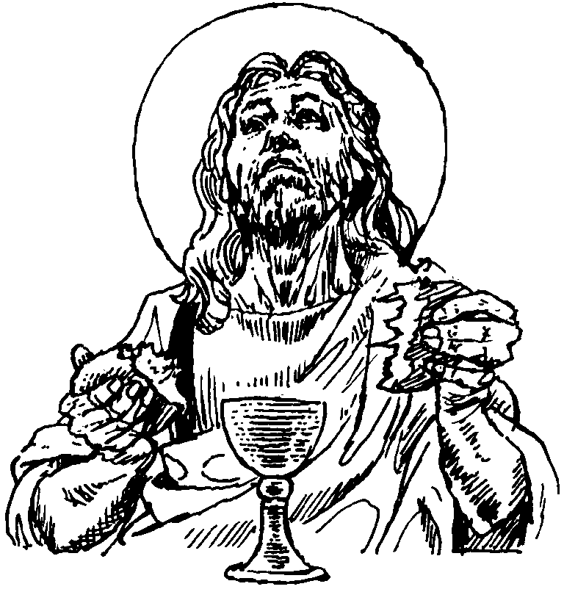
who, in the same night that he was betrayed,
took bread and gave you thanks;
he broke it and gave it to his disciples, saying:
Take, eat; this is my body which is given for you;
do this in remembrance of me.
In the same way, after supper
he took the cup and gave you thanks;
he gave it to them, saying:
Drink this, all of you;
this is my blood of the new covenant,
which is shed for you and for many for the forgiveness of sins.
Do this, as often as you drink it, in remembrance of me.
Christ has died:
Christ is risen:
Christ will come again.

And so, Father, calling to mind his death on the cross,
his perfect sacrifice made once for the sins of the whole world;
rejoicing in his mighty resurrection and glorious ascension,
and looking for his coming in glory,
we celebrate this memorial of our redemption.
As we offer you this our sacrifice of praise and thanksgiving,
we bring before you this bread and this cup
and we thank you for counting us worthy
to stand in your presence and serve you.

Send the Holy Spirit on your people
and gather into one in your kingdom
all who share this one bread and one cup,
so that we, in the company of Mary the Mother of Christ,
St John the Baptist, St James and all your saints
may praise and glorify you for ever,
through Jesus Christ our Lord;
by whom, and with whom, and in whom,
in the unity of the Holy Spirit,
all honour and glory be yours, almighty Father,
for ever and ever. Amen.
The Lord’s Prayer
Rejoicing in God’s new creation,
as our Saviour taught us, so we pray

Our Father, who art in heaven,
hallowed be thy name;
thy kingdom come;
thy will be done;
on earth as it is in heaven.
Give us this day our daily bread.
And forgive us our trespasses,
as we forgive those who trespass against us.
And lead us not into temptation;
but deliver us from evil.
For thine is the kingdom,
the power and the glory,
for ever and ever.
Amen.

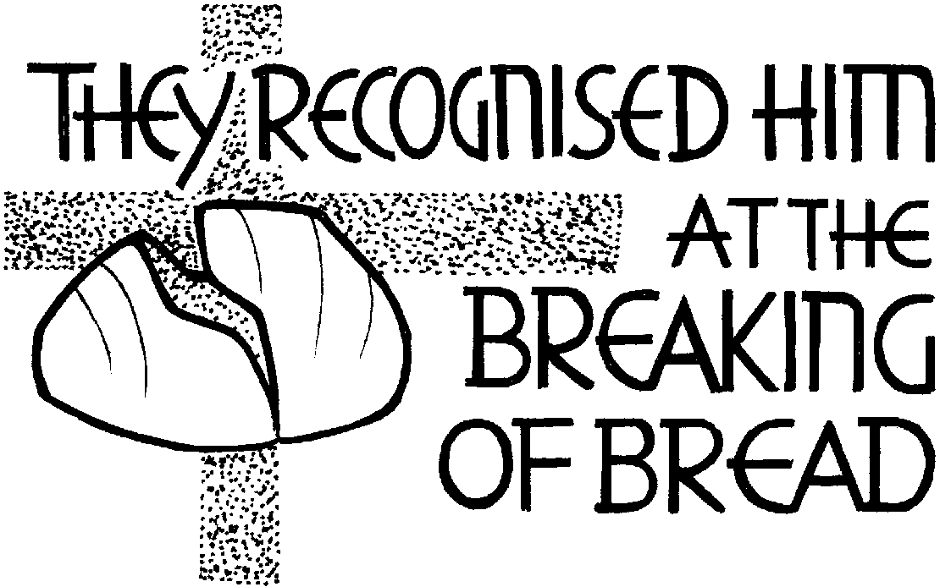

Breaking of the Bread
Jesus says, I am the bread of life,
whoever eats this bread will live for ever.
Lord, our hearts hunger for you;
give us this bread always.

Giving of Communion
The president says the invitation to communion

Alleluia! Christ our Passover has been sacrificed for us,
Therefore let us keep the feast. Alleluia!

All are welcome at the table of Jesus Christ, for he bids us come.
If you would like to come for a blessing please bring this service book with you.
Communion Hymn: 805 There is a Redeemer

We pray after Communion
We stand to pray together

Living God,
your Son made himself known to his disciples
in the breaking of bread:
open the eyes of our faith,
that we may see him in all his redeeming work;
who is alive and reigns, now and for ever. Amen.
Hymn: 667 I danced in the morning when the world was begun

We go out to serve God
The Dismissal
Alleluia. Christ is risen.
He is risen indeed. Alleluia.
Praise the God and Father of our Lord Jesus Christ.
He has given us new life and hope.
He has raised Jesus from the dead.
God has claimed us as his own.
He has brought us out of darkness.
He has made us light to the world.
Alleluia. Christ is risen.
He is risen indeed. Alleluia.

Let us bow our heads to receive God’s blessing.
May Christ,
who out of defeat brings new hope and a new future,
fill you with his new life;
and the blessing of God Almighty,
Father, Son and Holy Spirit,
be among you and
remain with you this day and always. Amen.

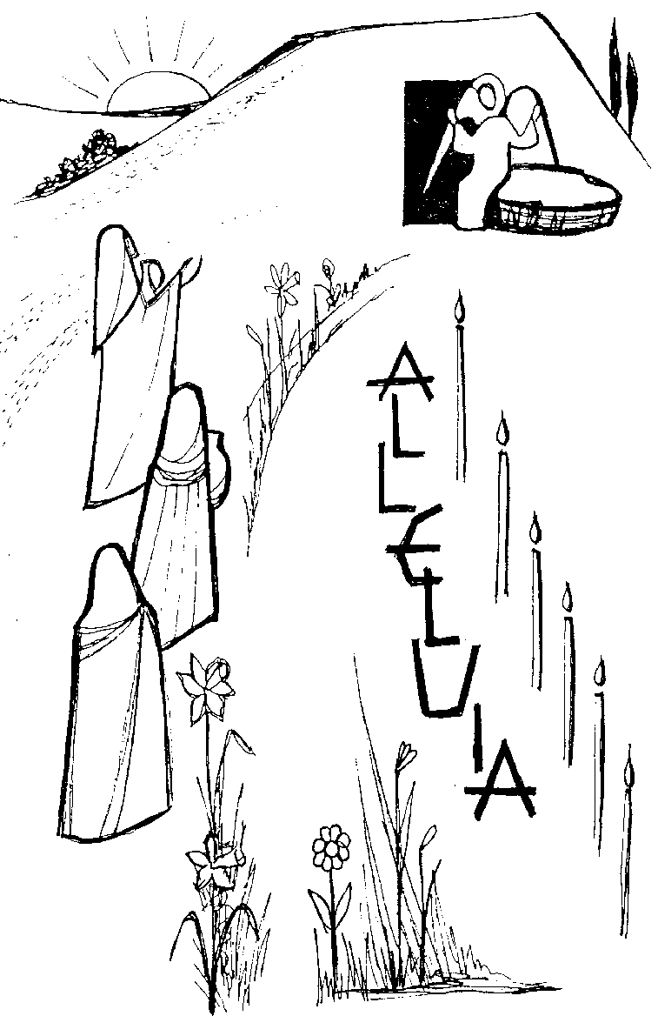
The deacon dismisses the congregation:
With the power that raised Jesus from the dead at work within you,
go in peace to love and serve the Lord. Alleluia, alleluia!
In the name of Christ. Amen. Alleluia, alleluia!

